Demo1 :

<https://developer.salesforce.com/docs/atlas.en-us.sfdx_setup.meta/sfdx_setup/sfdx_setup_install_cli.htm>

Enable dev hub in Salesforce org

Creating the LWC with CLI :

Step 1: create a project :

sfdx force:project:create --projectname lws-hello-world

## Step2: Authorize Your Dev Hub Org

sfdx force:auth:web:login

## step3: Create a Default Scratch Org

sfdx force:org:create -s -f config/project-scratch-def.json -a "lwchelloworld"

## step 4: Create a Lightning Web Componen

cd force-app/main/default/lwc

sfdx force:lightning:component:create --type lwc -n helloWorld -d force-app/main/default/lwc

Add this code to the helloWorld.js file.

import { LightningElement**, api** } from 'lwc';

export default class HelloWorld extends LightningElement {

**@api name;**

}

Add this code to the helloWorld.html file.

<template>

**<lightning-card title="HelloWorld" icon-name="custom:custom14">**

**<div class="slds-card__body slds-card__body_inner">**

**Hello, {name}!**

**</div>**

**</lightning-card>**

</template>

## helloWorld.js-meta.xml

*<?xml version="1.0" encoding="UTF-8"?>*

<LightningComponentBundle xmlns="http://soap.sforce.com/2006/04/metadata" fqn="anotherComponent">

<apiVersion>45.0</apiVersion>

<isExposed>**true**</isExposed>

**<masterLabel>Hello World</masterLabel>**

**<description>Add a classic greeting to any page.</description>**

**<targets>**

**<target>lightning__AppPage</target>**

**</targets>**

**<targetConfigs>**

**<targetConfig targets="lightning__AppPage">**

**<property name="name" type="String" label="Name" placeholder="World" description="Enter the name of the person to greet."/>**

**</targetConfig>**

**</targetConfigs>**

</LightningComponentBundle>

## Step 5:Deploy the project

Sfdx force:source:deploy –p force-app

sfdx force:source:deploy –p force-app –u <orgname(user name)>

## View the component in salesforce Org:

## https://developer.salesforce.com/docs/component-library/documentation/en/lwc/lwc.get_started_sfdx_hello_world

Demo 2: Visual code

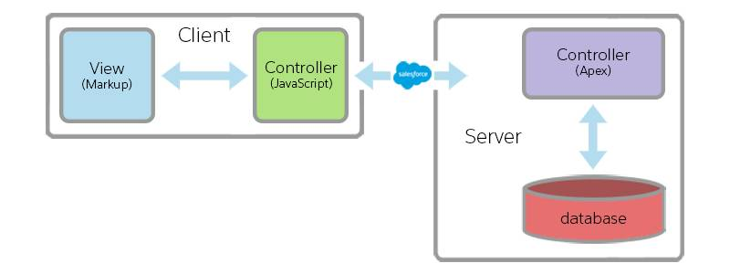

for editor: <https://developer.salesforce.com/docs/component-library/documentation/en/lwc/lwc.install_setup_develop>

Step 1:

Install the salesforce extension

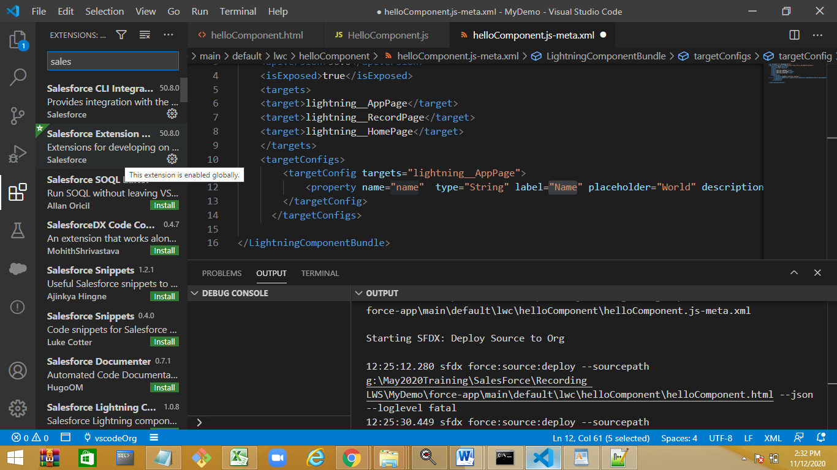

Ctrl+shift+p

Step 2: create a project

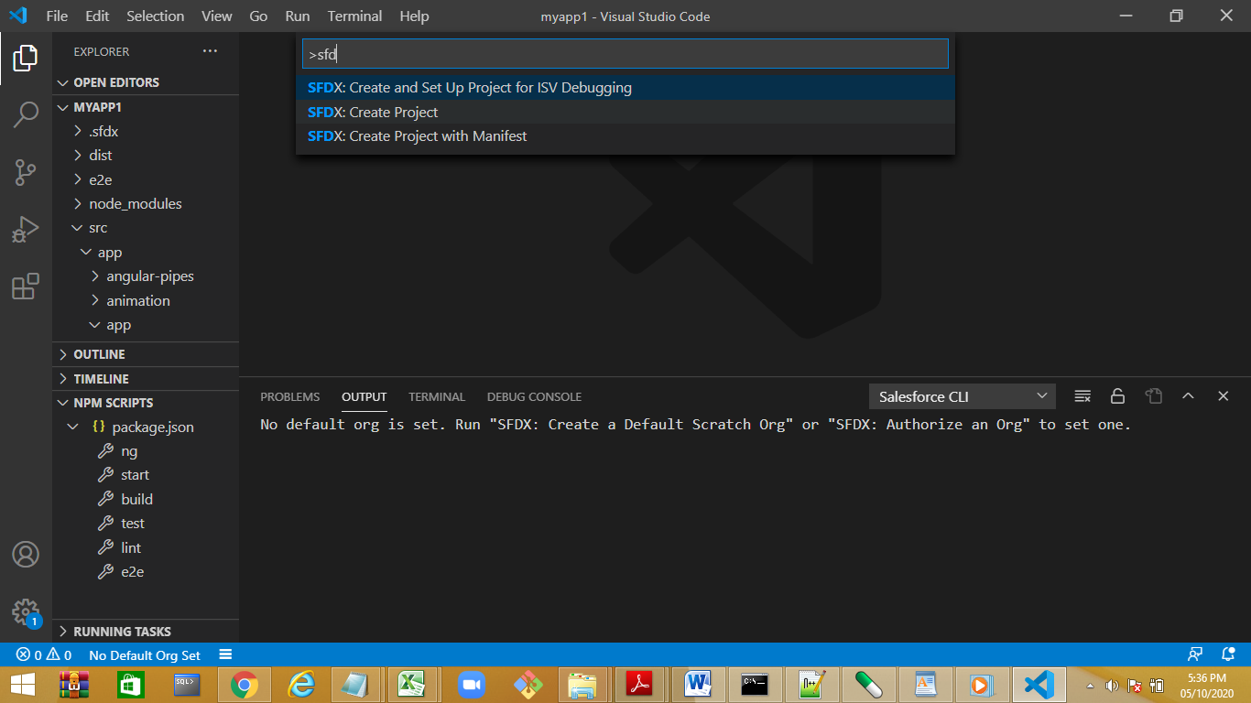

Create a standard project

Step 3:

Authorize the org

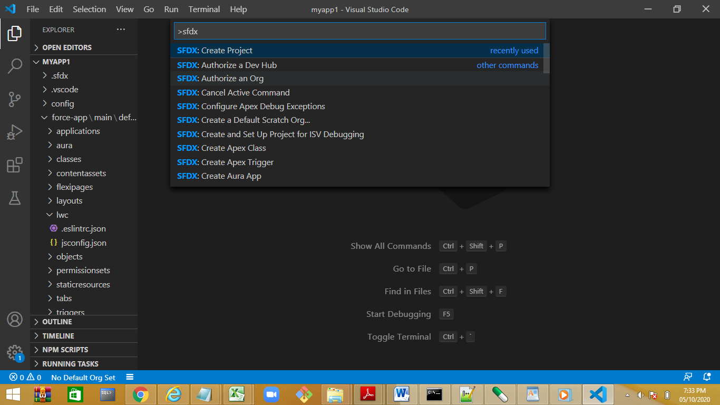

Step 4: create a LWC component.

Update the code

Step 5:deploy the component

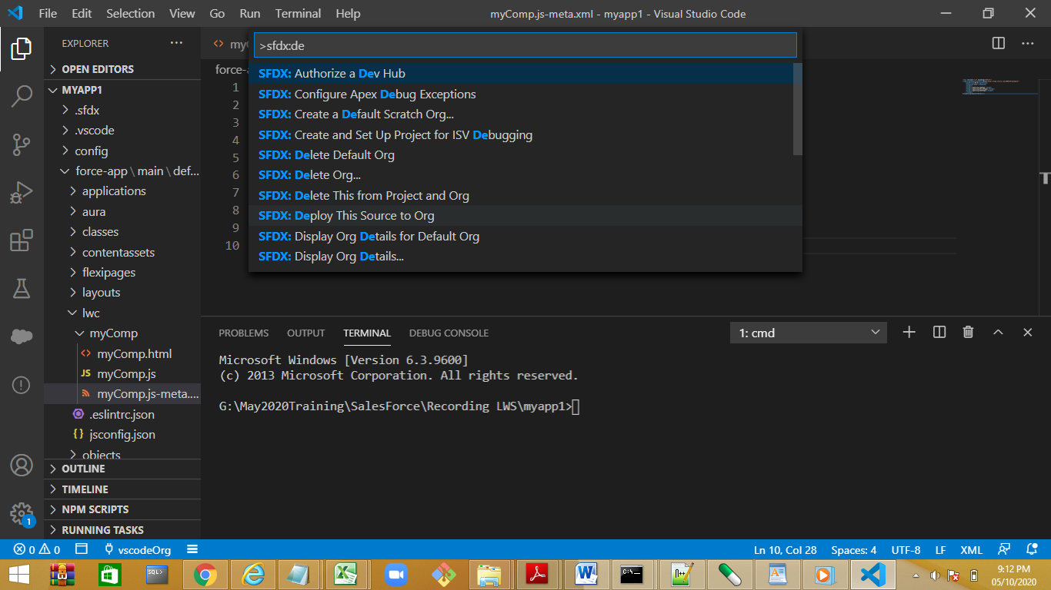

Switch to lightning experience --enter lightning component in search

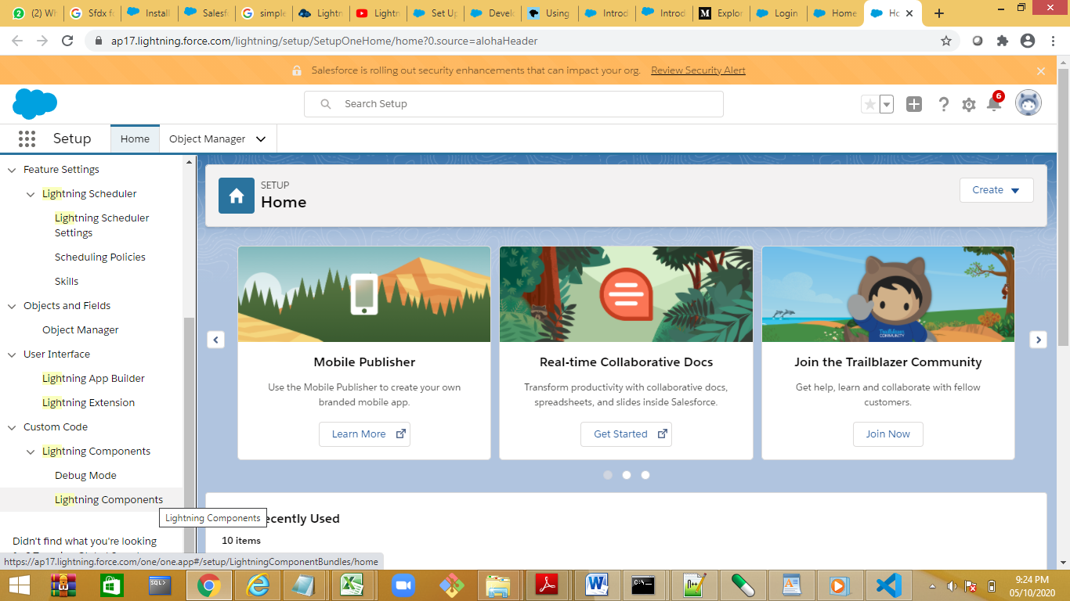

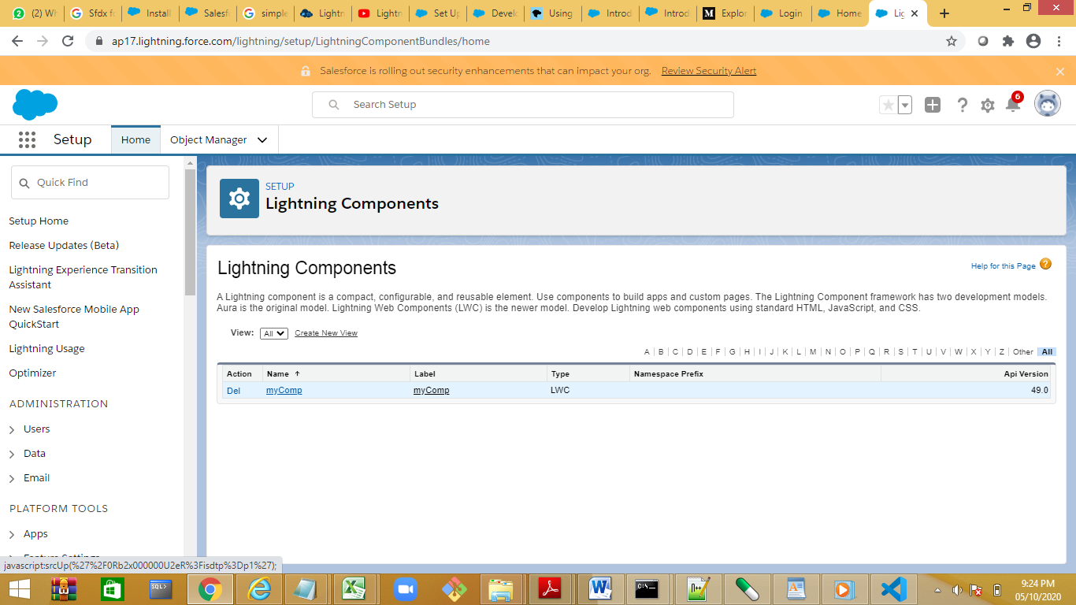

To view the component

1.use the salesforce standar pages

2.create a new page with lightning builder

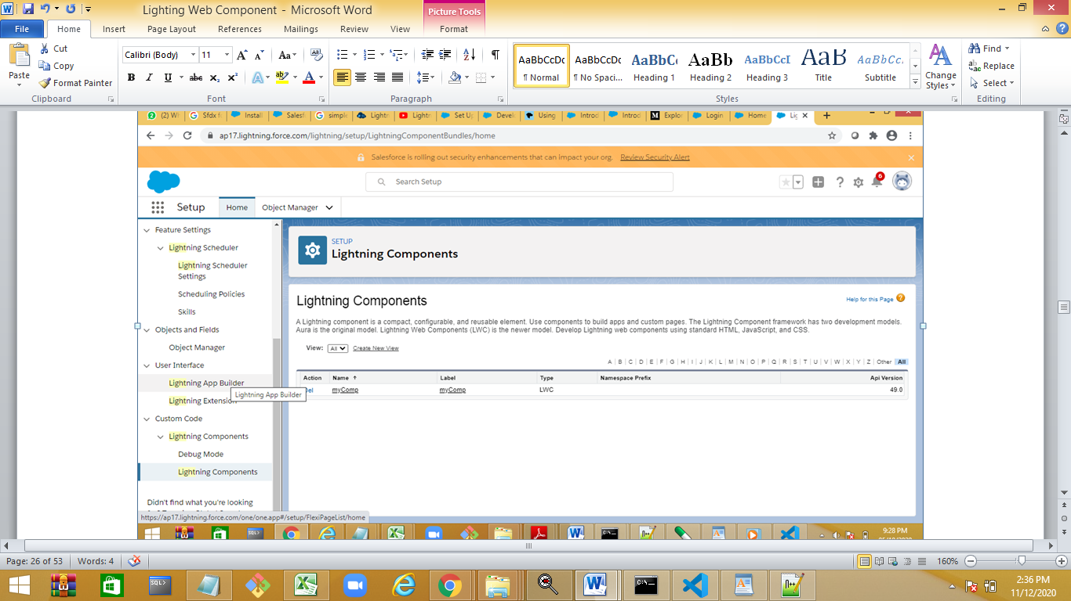

Event handling Demo:

<template>

    <lightning-card title="Event Demo" icon-name="custom:custom">

        <h1><font color='red'><b>{name}</b></font></h1>

        <lightning-input label="Enter Name" value={name} onchange={handleChange} ></lightning-input>

        <p class='slds-m-top_medium'>{uppercaseName}</p>

    </lightning-card>

</template>

import { LightningElement,api } from 'lwc';

export default class EventDemo extends LightningElement {

    @api name="Manisha";

    handleChange(event)

    {

       // alert ("event fired")

        this.name=event.target.value;

    }

    get uppercaseName()

    {

        return `${this.name}`.toUpperCase();

    }

}

Demo 2:

<template>

    <lightning-card title="Event Demo" icon-name="custom:custom">

        <p class='slds-m-top_medium'>{cmpName}</p>

        <h1><font color='red'><b>{name}</b></font></h1>

        <lightning-input label="Enter Name" value={name} onchange={handleChange} ></lightning-input>

        <p class='slds-m-top_medium'>{uppercaseName}</p>

    </lightning-card>

    <lightning-card title ="Enter Emp Data">

        <lightning-input label="Enter Name" onchange={handleChange} value={ename} name="a"></lightning-input><br/>

        <lightning-input label="Enter Company Name " onchange={handleChange} value={cmp} name="b"></lightning-input><br/>

        <lightning-button label="Click" onclick={getData} ></lightning-button>

</lightning-card>

<lightning-card title="Display Emp Data">

    <lightning-formatted-rich-text  value={ename}></lightning-formatted-rich-text><br/>

    <lightning-formatted-rich-text value={cmp}></lightning-formatted-rich-text><br/>

    <lightning-formatted-email value={email} hide-icon></lightning-formatted-email><br/>

    <lightning-formatted-phone value={phn}></lightning-formatted-phone>

</lightning-card>

</template>

import { LightningElement,api } from 'lwc';

export default class EventDemo extends LightningElement {

    @api name="Manisha";

    @api ename;

    @api cmp="Atos Syntel Pvt Ltd"

    @api email

    @api phn;

    handleChange(event)

    {

        //alert ("event fired")

      if(event.target.name=='a')

      {

        this.ename=event.target.value;

        this.email=this.ename+"@atos.net";

        console.log(this.ename)

      }

        //console.log("a:="+event.target.name);

        else if (event.target.name=='b')

        {

            this.cmp=event.target.value;

            console.log(this.cmp)

        }

    }

    get uppercaseName()

    {

        return `${this.name}`.toUpperCase();

    }

    getData(event)

    {

        alert("welome to evet handling");

        this.email=this.ename+"@atos.net";

    }

}

Nested Component helloComponent🡪eventComponent

<template>

    <lightning-card title="HelloWorld" icon-name="custom:custom14">

    <div>

    hello, {name } welcome to LWS

    </div>

    </lightning-card>

    <c-event-demo></c-event-demo>

    </template>

Fields , properties and attributes

Import the @api decorator from lwc. This code exposes the  field as a public property.

While defining component property use camel casing

If helloComponent--<c-hello-component>

@api itemName🡪item-name will become the attribute in Html

Demo:create 2 component todoItem and todoApp

import { api, LightningElement } from 'lwc';

export default class TodoItem extends LightningElement {

    @api itemName='Apple';

}

<template>

    <div class="view">

        <lightning-card title="Item Details">

            <label>{itemName}</label>

        </lightning-card>

    </div>

</template>

import { LightningElement } from 'lwc';

export default class TodoApp extends LightningElement {}

<template>

    <lightning-card title="Item List">

        <div class="listing">

            <c-todo-item item-name="Milk.."></c-todo-item>

            <c-todo-item item-name="Bread"></c-todo-item>

        </div>

    </lightning-card>

</template>

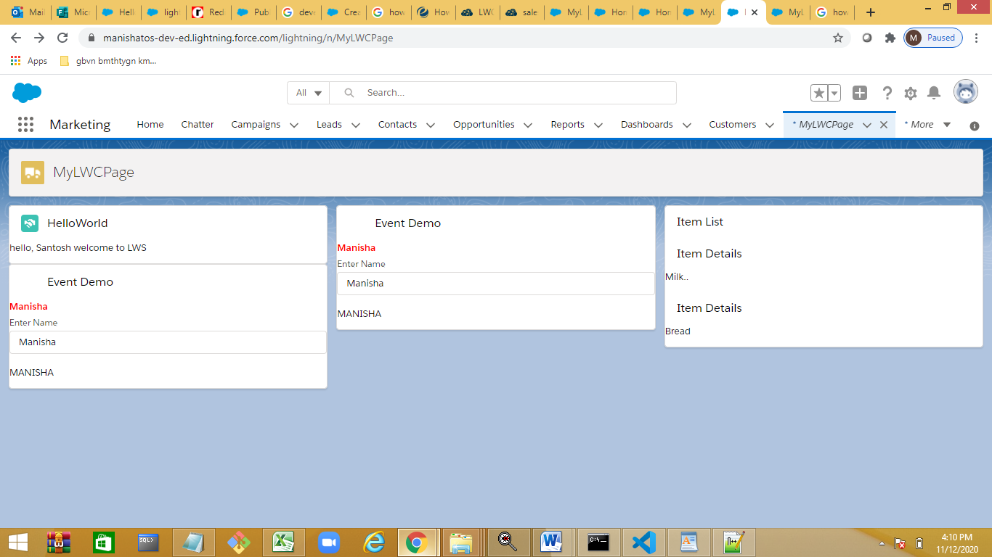

https://developer.salesforce.com/docs/component-library/bundle/lightning-formatted-phone/examplehttps://developer.salesforce.com/docs/component-library/bundle/lightning-formatted-phone/example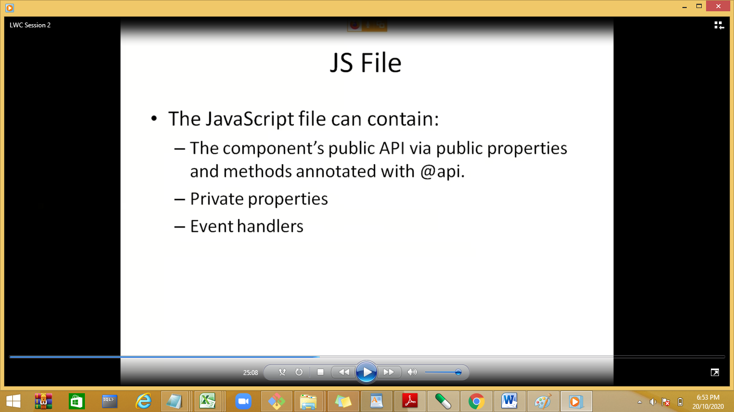

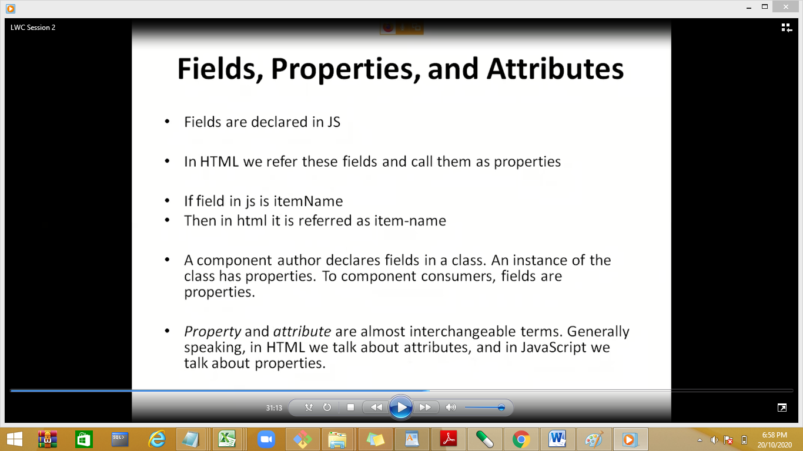

@api with method:

<https://developer.salesforce.com/docs/component-library/bundle/lightning-formatted-phone/example>

Lightning Data Services:

Use Lightning Data Service to load, create, edit, or delete a record in your component without requiring Apex code. Lightning Data Service handles sharing rules and field-level security for you.

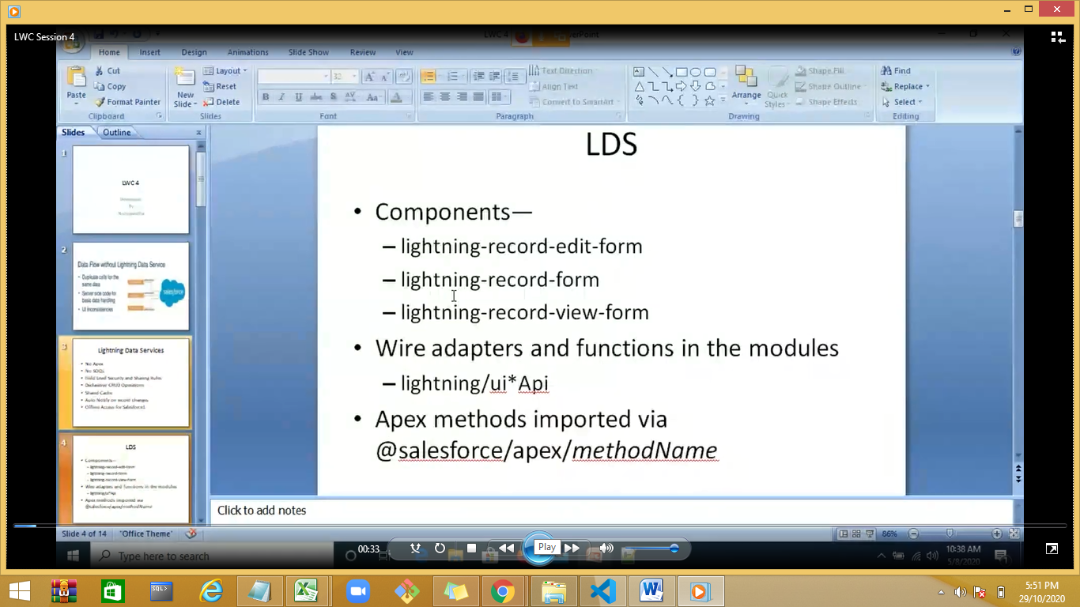

Records loaded in Lightning Data Service are cached and shared across components. If a page is composed of components showing the same record, all components show the same version of the record.

Lightning Data Service does a lot of work to make code perform well.

* Loads record data progressively.
* Caches results on the client.
* Invalidates cache entries when dependent Salesforce data and metadata changes.
* Optimizes server calls by bulkifying and deduping requests.

To improve performance, Lightning Data Service maintains a client-side cache of record data that has been loaded via a wire adapter

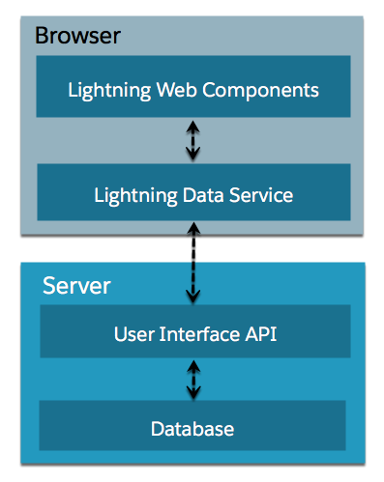

Lightning Data Service is built on top of [User Interface API](https://developer.salesforce.com/docs/atlas.en-us.uiapi.meta/uiapi/). UI API is a public Salesforce API that Salesforce uses to build Lightning Experience and Salesforce for iOS and Android. Like its name suggests, UI API is designed to make it easy to build Salesforce UI.

UI API gives you data and metadata in a single response. Responses match layout changes made to the org by Salesforce admins. If an admin removes a field from a layout, that field isn’t included in a response to a request for layout metadata.

UI API responses also respect CRUD access, field-level security settings, and sharing settings.

## Creating Components that Use Lightning Data Service

Lightning Data Service is available through several base components. To create a form for working with records, use lightning:recordForm, lightning:recordEditForm, or lightning:recordViewForm. If you need more customization than those components allow, consider the force:recordData component

Base component

lightning:recordForm

Display, create, or edit records

lightning:recordViewForm

Display records with lightning:outputField

lightning:recordEditForm

Create or edit records with lightning:inputField

force:recordData

Lightning Component comparison

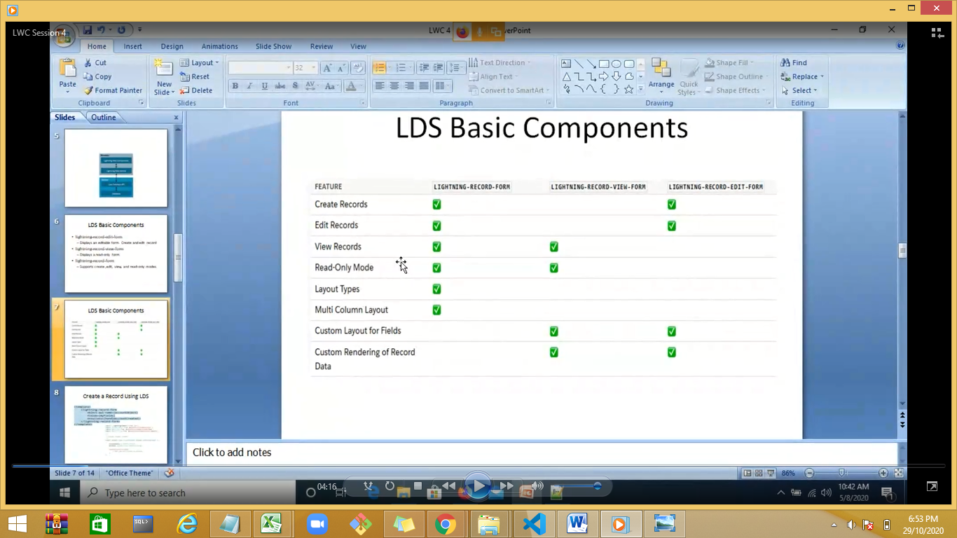

Record-view-form demo: Display records with lightning:outputField

The object-api-name attribute is always required, and the record-id is required only when you’re editing or viewing a record.

<template>

    <div class="slds-p-bottom_large slds-p-left_large" style="width:500px">

        <lightning-input value={recordId} onchange={handleChange} label="Enter Contact Id"></lightning-input>

        <lightning-record-view-form

                record-id={recordId}

                object-api-name="Contact">

        <div class="slds-box">

            <lightning-output-field field-name="Name">

            </lightning-output-field>

            <lightning-output-field field-name="Birthdate">

            </lightning-output-field>

            <lightning-output-field field-name="Phone">

            </lightning-output-field>

            <lightning-output-field field-name="LeadSource">

            </lightning-output-field>

        </div>

        </lightning-record-view-form>

    </div>

</template>

import { LightningElement,api } from 'lwc';

export default class LwsDataComp extends LightningElement {

    @api recordId="0032w00000K2aMB";

    handleChange(event)

    {

        this.recordId=event.target.value;

    }

}

lightning-record-edit-form:

https://www.sfdcpoint.com/salesforce/lightning-record-edit-form-lwc/

Use the lightning-record-edit-form component to create a form that's used to add a Salesforce record or update fields in an existing record on an object

#### Creating a Record

To enable record creation, pass in the object API name for the record to be created. Specify the fields you want to include in the record create layout using lightning-input-field components.

    <template>

        <div class="slds-p-bottom_large slds-p-left_large" style="width:500px">

           <!-- <lightning-input value={recId} label="Enter Record id to Update" onchange={handleChange}>

            </lightning-input>-->

            <lightning-record-edit-form

                        id="recordEditForm"

                        title="Adding a New Record"

                        object-api-name="Contact" onsuccess={handleSuccess}

                        onsubmit ={handleSubmit}>

                <lightning-messages></lightning-messages>

                <lightning-input-field field-name="FirstName">

                </lightning-input-field>

                <lightning-input-field field-name="LastName">

                </lightning-input-field>

                <lightning-input-field field-name="Birthdate">

                </lightning-input-field>

                <lightning-input-field field-name="Phone">

                </lightning-input-field>

                <!--Picklist-->

                <lightning-input-field field-name="LeadSource">

                </lightning-input-field>

                <lightning-button type="submit"

                            label="Add Record"

                            class="slds-m-top_medium">

                </lightning-button>

            </lightning-record-edit-form>

        </div>

</template>

import { LightningElement,api } from 'lwc';

export default class EditFormDemo extends LightningElement {

handleSuccess(event) {

    console.log('onsuccess event recordEditForm', event.detail.id);

}

handleSubmit(event) {

    console.log('onsubmit event recordEditForm'+ event.detail.fields);

}

}

#### Editing a Record

To enable record editing, pass in the ID of the record and the corresponding object API name to be edited. Specify the fields you want to include in the record edit layout using lightning-input-field

    <template>

        <div class="slds-p-bottom_large slds-p-left_large" style="width:500px">

           <lightning-input value={recId} label="Enter Record id to Update" onchange={handleChange}>

            </lightning-input>

            <lightning-record-edit-form

                        id="recordEditForm"

                        title="Updating Existing Record"

                        record-id={recId}

                        object-api-name="Contact" onsuccess={handleSuccess}

                        onsubmit ={handleSubmit}>

                <lightning-messages></lightning-messages>

                <lightning-input-field field-name="FirstName">

                </lightning-input-field>

                <lightning-input-field field-name="LastName">

                </lightning-input-field>

                <lightning-input-field field-name="Birthdate">

                </lightning-input-field>

                <lightning-input-field field-name="Phone">

                </lightning-input-field>

                <!--Picklist-->

                <lightning-input-field field-name="LeadSource">

                </lightning-input-field>

                <lightning-button type="submit"

                            label="Update Record"

                            class="slds-m-top_medium">

                </lightning-button>

            </lightning-record-edit-form>

        </div>

</template>

import { LightningElement,api } from 'lwc';

export default class EditFormDemo extends LightningElement {

@api recId;

event recordEditForm', event.detail.id);

}

handleChange(event)

{

    this.recId=event.target.value;

}

handleSuccess(event) {

    console.log('onsuccess

handleSubmit(event) {

    console.log('onsubmit event recordEditForm'+ event.detail.fields);

}

}

lightning-record-form : edit,create,dispaly

The component accepts a mode value that determines the user interaction allowed for the form. The value for mode can be one of the following:

* edit - Creates an editable form to add a record or update an existing one. When updating an existing record, specify the record-id. Edit mode is the default when record-id is not provided, and displays a form to create new records.
* view - Creates a form to display a record that the user can also edit. The record fields each have an edit button. View mode is the default when record-id is provided.
* readonly - Creates a form to display a record without enabling edits. The form doesn't display any buttons.

#### Specifying Record Fields

For all modes, the component expects the fields attribute or the layout-type attribute.

Use the fields attribute to pass record fields as an array of strings. The fields display in the order you list them.

Use the layout-type attribute to specify a Full or Compact layout. Layouts are typically defined (created and modified) by administrators. Specifying record data using layout-type loads the fields in the layout definition. All fields that have been assigned to the layout are loaded into the form. This behavior is the same as the Lightning Data Service's [getRecordUi wire adapter](https://developer.salesforce.com/docs/component-library/bundle/lightning-record-form/docs/component-library/documentation/lwc/lwc.reference_wire_adapters_record_ui).

To see the fields in the layout types in your org:

* Full - The full layout corresponds to the fields on the record detail page. From the management settings for the object that you want to edit, go to Page Layouts.
* Compact - The compact layout corresponds to the fields on the highlights panel at the top of the record. From the management settings for the object that you want to edit, go to Compact Layouts.

Demo readOnly mode

    <template>

        <lightning-card>

            <h1 slot="title">

                <lightning-icon icon-name="utility:connected_apps" size="small"></lightning-icon>

                Record Form

            </h1>

            <div slot="footer">

            </div>

            <div>

            <!-- fields={fields} -->

            <lightning-record-form

                    record-id={recordId}

                    object-api-name={objectApiName}

                    layout-type="Full"

                    columns="2"

                    mode={modeName}

                   >

            </lightning-record-form>

        </div>

        </lightning-card>

    </template>

import { LightningElement,api } from 'lwc';

import { ShowToastEvent } from 'lightning/platformShowToastEvent';

//import PHONE  from '@salesforce/schema//Contact.Phone';

export default class EditFormDemo extends LightningElement {

    @api recId="0032w00000P0FUB";

      fields = ['Name', 'AnnualRevenue', 'Industry'];

      modeName ='readOnly';

      objectApiName = 'Account';

      recordId = '0012w00000NsAwx';

}

Demo View mode

    <template>

        <lightning-card>

            <h1 slot="title">

                <lightning-icon icon-name="utility:connected_apps" size="small"></lightning-icon>

                Record Form

            </h1>

            <div slot="footer">

            </div>

            <div>

            <!-- fields={fields} -->

            <lightning-record-form

                    record-id={recordId}

                    object-api-name={objectApiName}

                    layout-type="Compact"

                    columns="2"

                    mode={modeName}

                    onsuccess={handleSuccess} onsubmit={handleSubmit}

                   >

            </lightning-record-form>

        </div>

        </lightning-card>

    </template>

import { LightningElement,api } from 'lwc';

import { ShowToastEvent } from 'lightning/platformShowToastEvent';

//import PHONE  from '@salesforce/schema//Contact.Phone';

export default class EditFormDemo extends LightningElement {

    @api recId="0032w00000P0FUB";

      fields = ['Name', 'AnnualRevenue', 'Industry'];

      modeName ='view';

      objectApiName = 'Account';

      recordId = '0012w00000NsAwx';

     handleSubmit(event){

          event.preventDefault();       // stop the form from submitting

          const fields = event.detail.fields;

          fields.Name = 'Tushar Sharma'; // modify a field

          console.log('fields', fields);

          console.log('fields 2', fields.Name);

          this.template.querySelector('lightning-record-form').submit(fields);

       }

       handleSuccess(event) {

          console.log('fields');

          const evt = new ShowToastEvent({

              title: "Account updated",

              message: "Record ID: " + event.detail.id,

              variant: "success"

          });

          this.dispatchEvent(evt);

      }

}

Demo edit mode

@wire

The wire service provisions an immutable stream of data to the component. Each value in the stream is a newer version of the value that precedes it.

We call the wire service reactive in part because it supports reactive variables, which are prefixed with $. If a reactive variable changes, the wire service provisions new data. We say “provisions” instead of “requests” or “fetches” because if the data exists in the client cache, a network request may not be involved.

<https://www.sfdcamplified.com/2020/08/access-data-using-wire-lwc.html>

Demo1 :

<template>

    <lightning-card title="PropertyWireDemo" icon-name="custom:custom63">

        <div class="slds-m-around_medium">

            <lightning-button onclick={showData} label="Show"></lightning-button>

          {cname}

        </div>

    </lightning-card>

</template>

import { LightningElement ,api,wire} from 'lwc';

import {getRecord} from 'lightning/uiRecordApi';

const FIELDS = [

    'Contact.Name',

    'Contact.Title',

    'Contact.Phone',

    'Contact.Email',

];

export default class WireDemo1 extends LightningElement {

    @api recordId='0032w00000P0FUB';

    @wire(getRecord, { recordId: '$recordId', fields: FIELDS })

    contact;

    @api cname;

    showData(event)

    {

        alert(JSON.stringify(this.contact.data.fields.Name.value));

        this.cname=JSON.stringify(this.contact.data.fields.Name.value);

    }

}

Demo2: record Id Static

<template>

<lightning-card title="My Contact Record" icon-name="standard:contact">

**<template if:true={contact.data}>**

<div class="slds-m-around_medium">

<p>{name}</p>

<p>{title}</p>

<p><lightning-formatted-phone value={phone}></lightning-formatted-phone></p>

<p><lightning-formatted-email value={email}></lightning-formatted-email></p>

</div>

</template>

**<template if:true={contact.error}>**

<c-error-panel errors={contact.error}></c-error-panel>

</template>

</lightning-card>

</template>

import { LightningElement, api, wire } from 'lwc';

import { getRecord } from 'lightning/uiRecordApi';

const FIELDS = [

'Contact.Name',

'Contact.Title',

'Contact.Phone',

'Contact.Email',

];

export default class WireGetRecordDynamicContact extends LightningElement {

@api recordId;

@wire(getRecord, { recordId: '$recordId', fields: FIELDS })

contact;

get name() {

return this.contact.data.fields.Name.value;

}

get title() {

return this.contact.data.fields.Title.value;

}

get phone() {

return this.contact.data.fields.Phone.value;

}

get email() {

return this.contact.data.fields.Email.value;

}

}

Dynamic Record ID:

<template>

<lightning-card title="My Contact Record" icon-name="standard:contact">

**<template if:true={contact.data}>**

<div class="slds-m-around_medium">

<p>{name}</p>

<p>{title}</p>

<p><lightning-formatted-phone value={phone}></lightning-formatted-phone></p>

<p><lightning-formatted-email value={email}></lightning-formatted-email></p>

</div>

</template>

**<template if:true={contact.error}>**

<c-error-panel errors={contact.error}></c-error-panel>

</template>

</lightning-card>

</template>

import { LightningElement, api, wire } from 'lwc';

import { getRecord } from 'lightning/uiRecordApi';

const FIELDS = [

'Contact.Name',

'Contact.Title',

'Contact.Phone',

'Contact.Email',

];

export default class WireGetRecordDynamicContact extends LightningElement {

@api recordId;

@wire(getRecord, { recordId: '$recordId', fields: FIELDS })

contact;

get name() {

return this.contact.data.fields.Name.value;

}

get title() {

return this.contact.data.fields.Title.value;

}

get phone() {

return this.contact.data.fields.Phone.value;

}

get email() {

return this.contact.data.fields.Email.value;

}

}

@wire with method

import { LightningElement,api,wire ,track} from 'lwc';

import { getRecord } from 'lightning/uiRecordApi';

const FIELDS = [

    'Contact.Name',

    'Contact.Title',

    'Contact.Phone',

    'Contact.Email',

];

export default class WireContactDemo2 extends LightningElement {

    @api recordId="0032w00000P0FS3";

    @track record;

    @track error;

    @wire(getRecord, { recordId: '$recordId', fields: FIELDS })

    wiredContact({ error,data }) {

        if (data) {

            this.record = data;

            console.log(this.record);

            this.error = undefined;

        } else if (error) {

            this.error = error;

            console.log(this.error)

            this.record = undefined;

        }

    }

    get name() {

        return this.record.fields.Name.value;

    }

    get title() {

        return this.record.fields.Title.value;

    }

    get phone() {

        return this.record.fields.Phone.value;

    }

    get email() {

        return this.record.fields.Email.value;

    }

}

<template>

    <lightning-card title="My Contact Record" icon-name="standard:contact">

        <template if:true={record}>

             <div class="slds-m-around_medium">

                <p>{name}</p>

                <p>{title}</p>

                <p><lightning-formatted-phone value={phone}></lightning-formatted-phone></p>

                <p><lightning-formatted-email value={email}></lightning-formatted-email></p>

            </div>

        </template>

        <template if:true={error}>

            <c-error-panel errors={error}></c-error-panel>

        </template>

    </lightning-card>

</template>

Lwc for error handling

<template>

    <lightning-card title="Handle Error" icon-name="standard:contact">

        <template if:true={errors}>

            <p>{errors}</p>

        </template>

    </lightning-card>

</template>

import { LightningElement,api } from 'lwc';

export default class ErrorPanel extends LightningElement {

    @api errors;

}

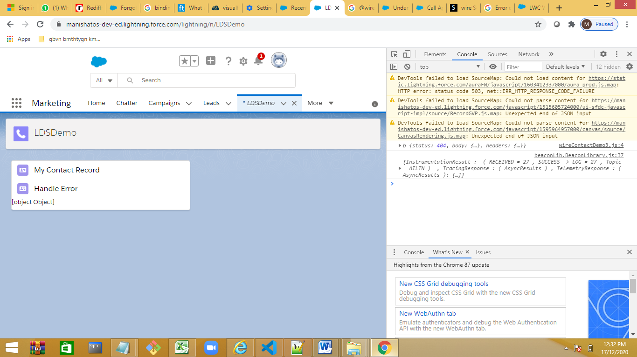

Error handling in @wire

<template>

<lightning-card title="Handle Error" icon-name="standard:contact">

<template if:true={error}>

<p>{error}</p>

</template>

</lightning-card>

</template>

import { LightningElement, api, wire, track } from 'lwc';

import { getRecord } from 'lightning/uiRecordApi';

const fields = [

*// This invalid field causes @wire(getRecord) to return an error*

'Contact.invalidField'

];

export default class WireGetRecordDynamicContact extends LightningElement {

@api recordId;

@track error;

@wire(getRecord, { recordId: '$recordId', fields })

wiredRecord({error, data}) {

if (error) {

this.error = 'Unknown error';

if (Array.isArray(error.body)) {

this.error = error.body.map(e => e.message).join(', ');

} else if (typeof error.body.message === 'string') {

this.error = error.body.message;

}

this.record = undefined;

} else if (data) {

*// Process record data*

}

}

}

Create a LWC for error

https://developer.salesforce.com/docs/component-library/documentation/en/lwc/lwc.data_wire_base_components

Calling Apex method in LWC

@wire @lightning web component are the mechanism we use to push the data form salesforce object , if we want to run a query then we use Apex Class

Demo on Apex Class:

Method has to public,static

To use Apex method we have to use @AuraEnabled Annotation

Cacheable—true—increase the performance , data will be there in cache

Demo:Apex class in LWS is used for firing query on join ,use rarely

Step 1:Create an Apex class with Name ContactController

public with sharing class ContactController1 {

@AuraEnabled(cacheable=true)

public static List<Contact> getContacts()

{

return [select name,title,phone,email from contact limit 10] ;

}

}

Step 2:Create a new LWC

import { LightningElement, wire } from 'lwc';

import getContacts from '@salesforce/apex/ContactController1.getContacts'

export default class ApexCompo extends LightningElement {

    @wire(getContacts)

    contacts;

}

.html code

<template>

    <lightning-card title="ApexWireMethodToProperty" icon-name="custom:custom63">

        <div class="slds-m-around_medium">

            <template if:true={contacts.data}>

                <template for:each={contacts.data} for:item="contact">

                   <p key={contact.Id}>{contact.Name}</p>

                </template>

            </template>

            <template if:true={contacts.error}>

                <c-error-panel errors={contacts.error}></c-error-panel>

            </template>

        </div>

    </lightning-card>

</template>

1. **Decorators**

Lightning Web Components has three decorators that add functionality to a property or function.

The ability to create decorators is part of ECMAScript, but these three decorators are unique to Lightning Web Components.

1. **@track** –  To track a private property’s value and rerender a component when it changes, decorate the property with @track. Tracked properties are also called private reactive properties.
2. **@api** – To expose a public property, decorate it with @api. Public properties define the API for a component. An owner component that uses the component in its markup can access the component’s public properties. Public properties are reactive. If the value of a reactive property changes, the component’s template rerenders any content that references the property.
3. **@wire** – To read Salesforce data, Lightning web components use a reactive wire service. When the wire service provisions data, the component rerenders. Components use @wire in their JavaScript class to specify a [wire adaptor](https://developer.salesforce.com/docs/component-library/documentation/lwc/reference_ui_api.html) or an Apex method.

Life Cycle

<template>

    <lightning-card title="Life Cycle Demo">

        <b>Welcome !!!!!!!!!!!!!!! </b>

    </lightning-card>

</template>

import { LightningElement } from 'lwc';

export default class LifeCycleDemo extends LightningElement {

    constructor() {

        super();

        console.log("object is initilized")

    }

    connectedCallback() {

        console.log("component added to DOM")

    }

    disconnectedCallback() {

        console.log("component removed to DOM")

    }

    renderedCallback()

    {

        console.log("component displayed")

    }

}

Life Cycle nested component.

Navigation in LWC

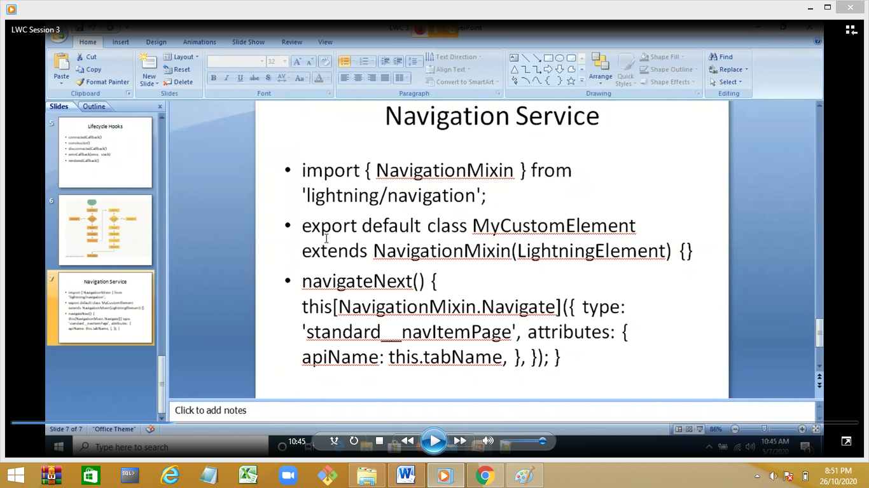

Create a LWC myNamedSlot

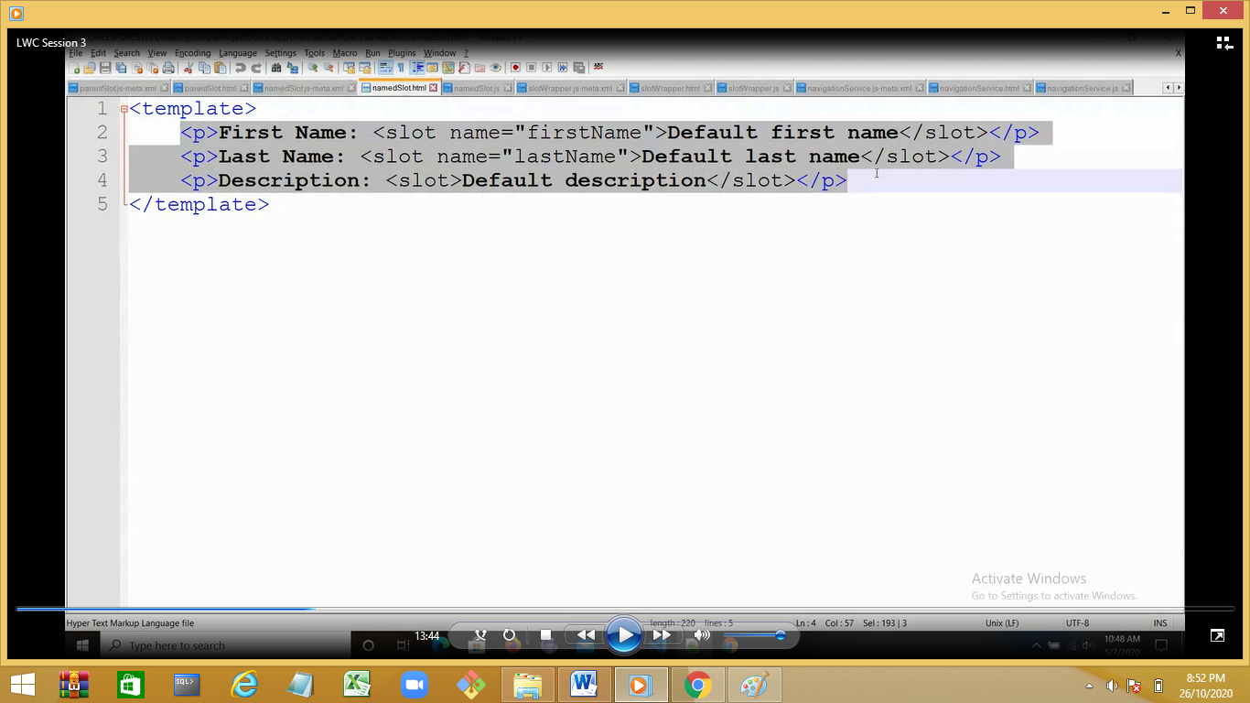

2 slots with name and 1 unnamed slot

Creat 1 more LWC myWrapperSlot

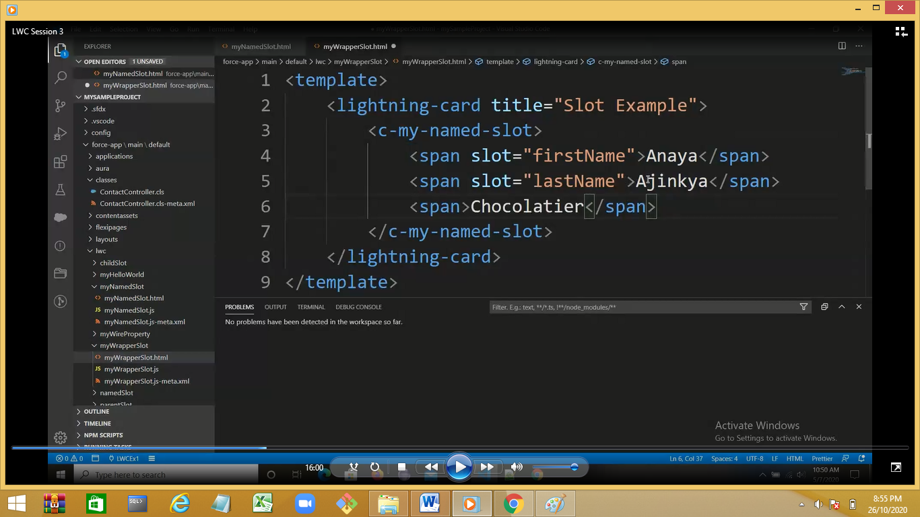

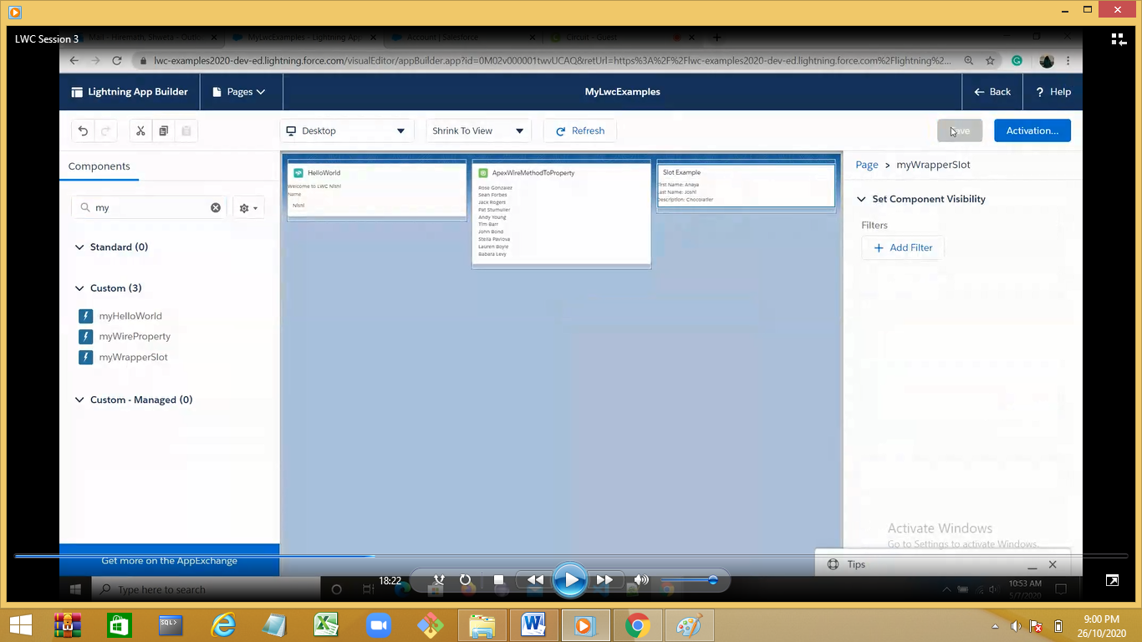

We can have only 1 unnamed slot in 1 template

Demo : comment the unnamed container and check

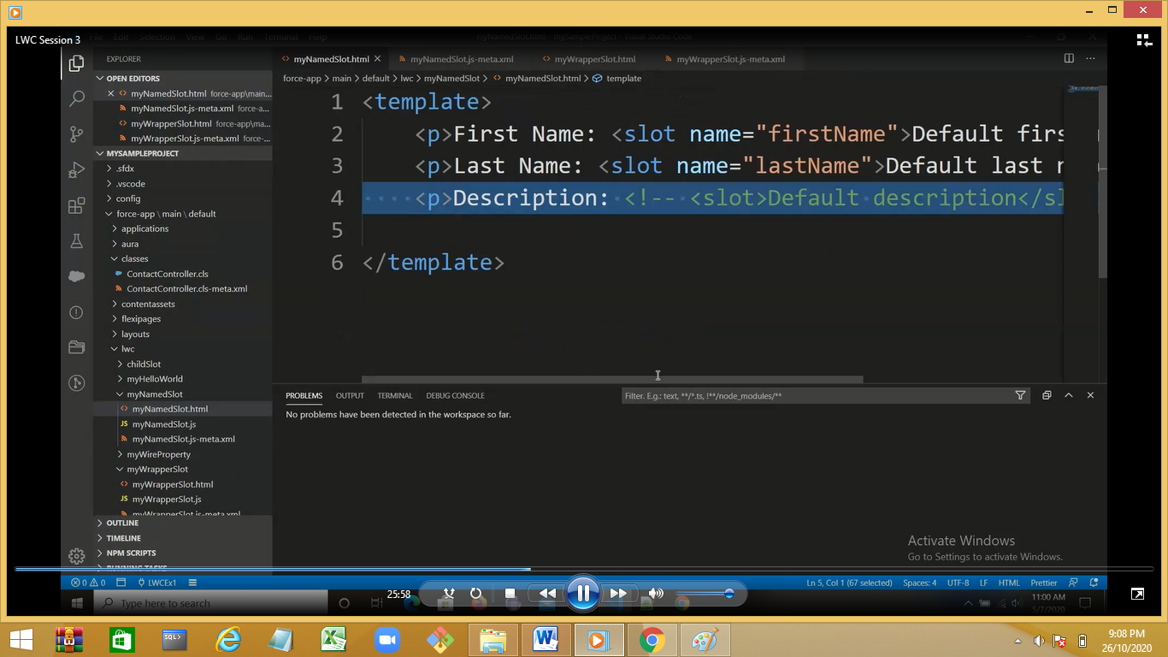

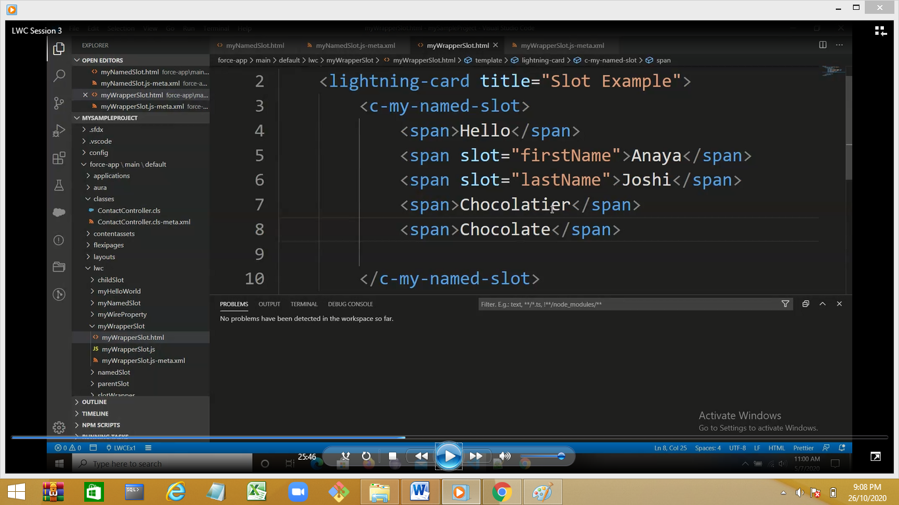

Demo:Slot example.

Create a WLC

myChildSlot

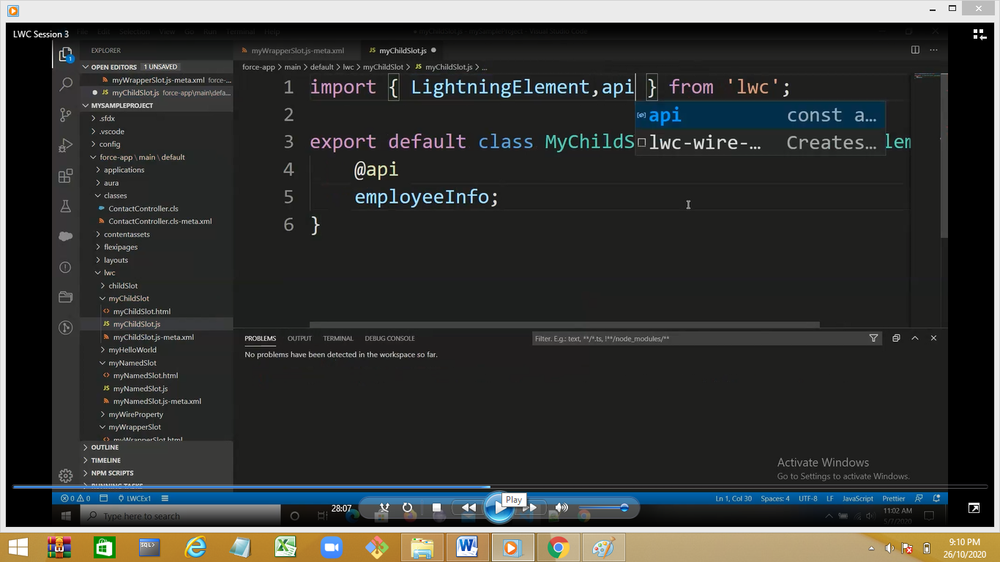

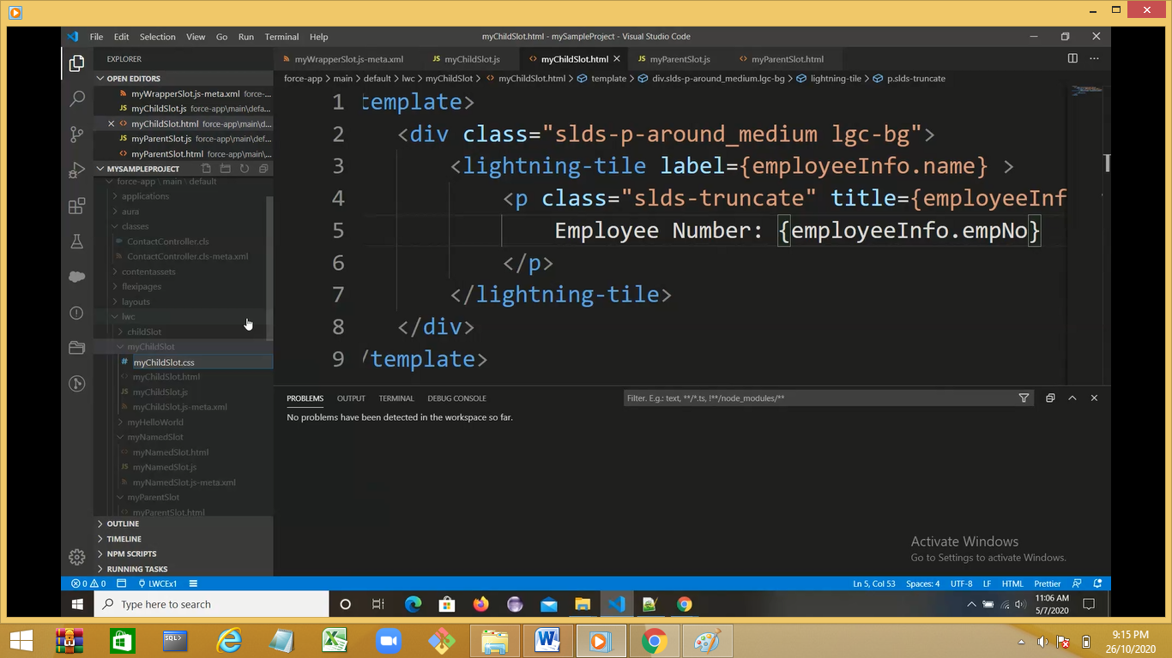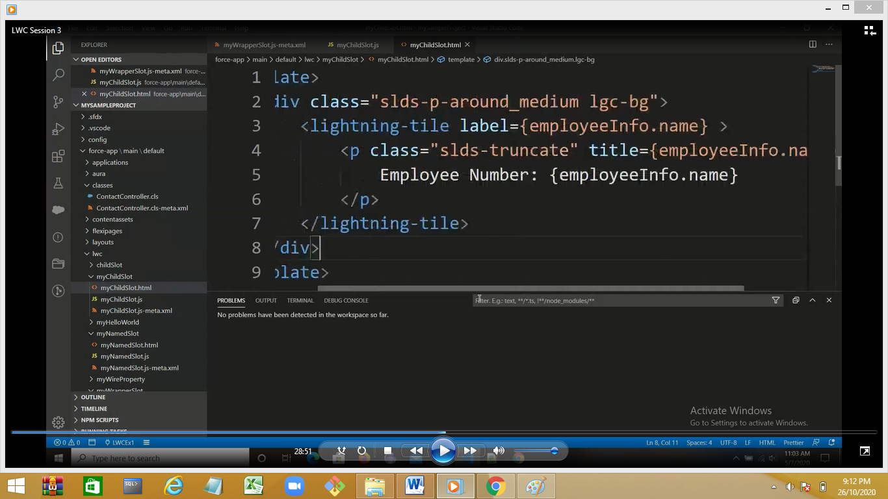

Create a myParentInfo

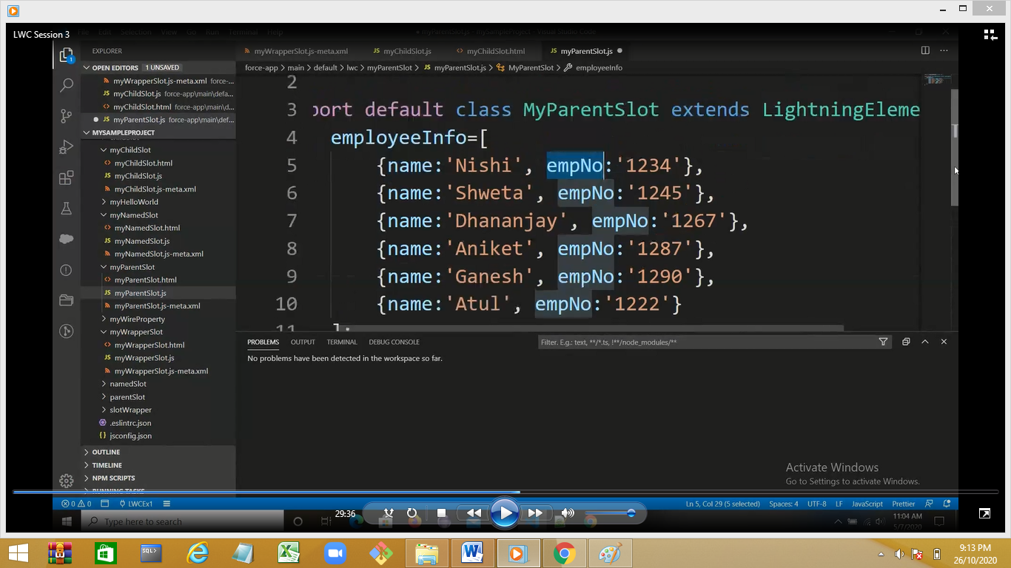

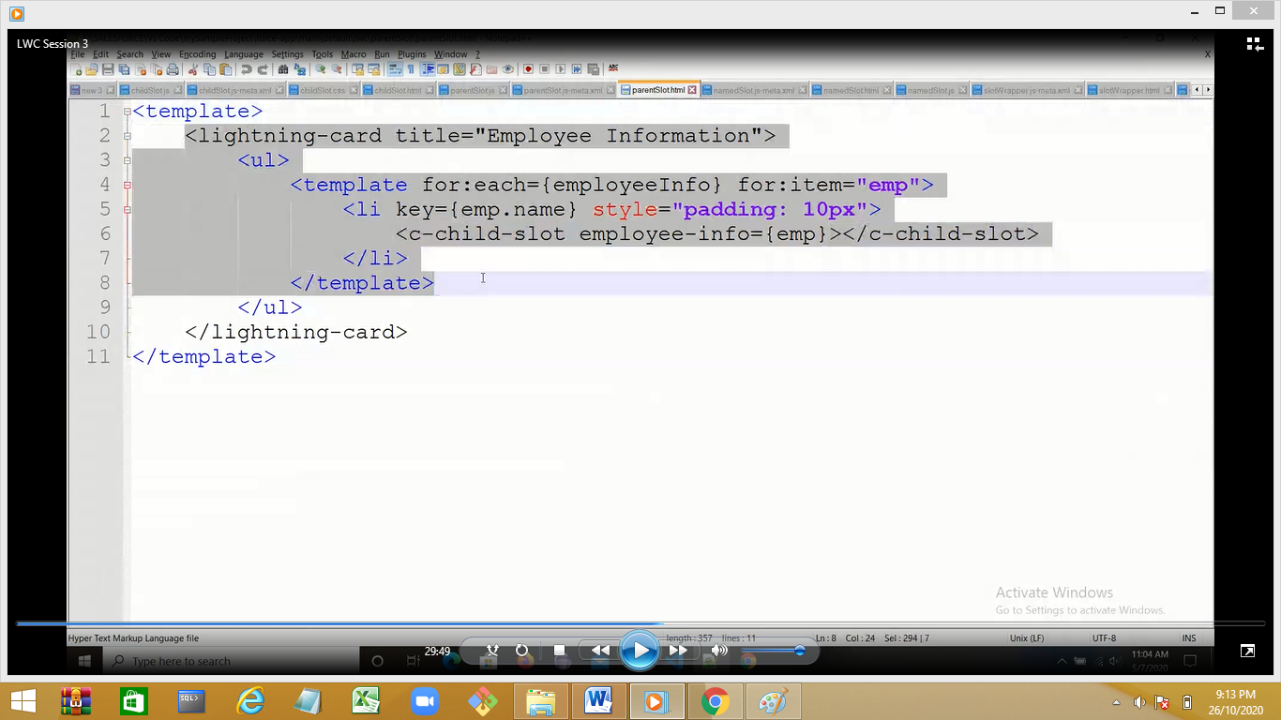

Add css file in child

https://developer.salesforce.com/docs/component-library/documentation/en/lwc/create_components_css

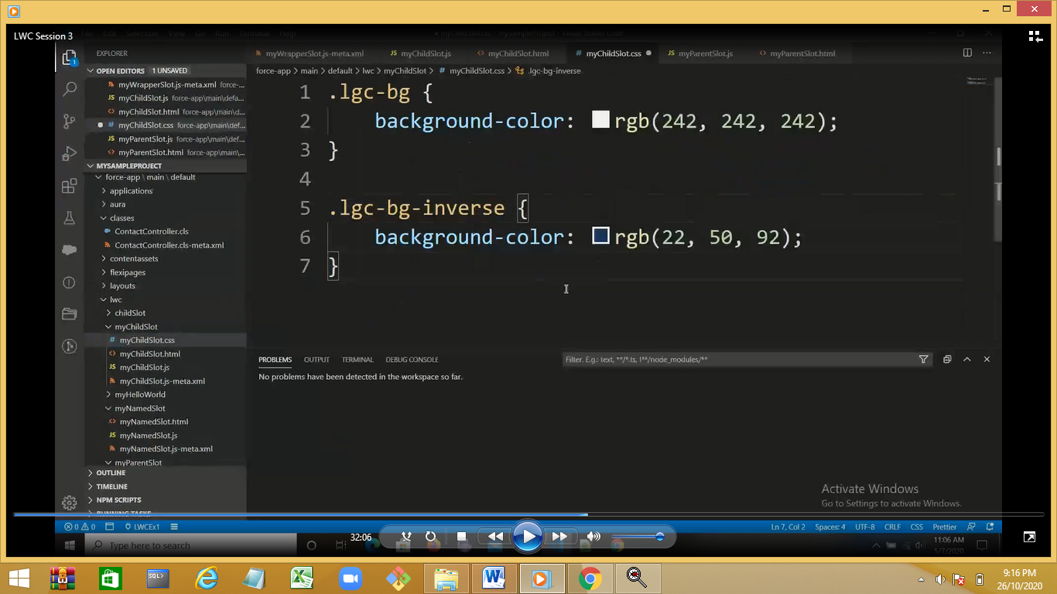

Deploy the component and output

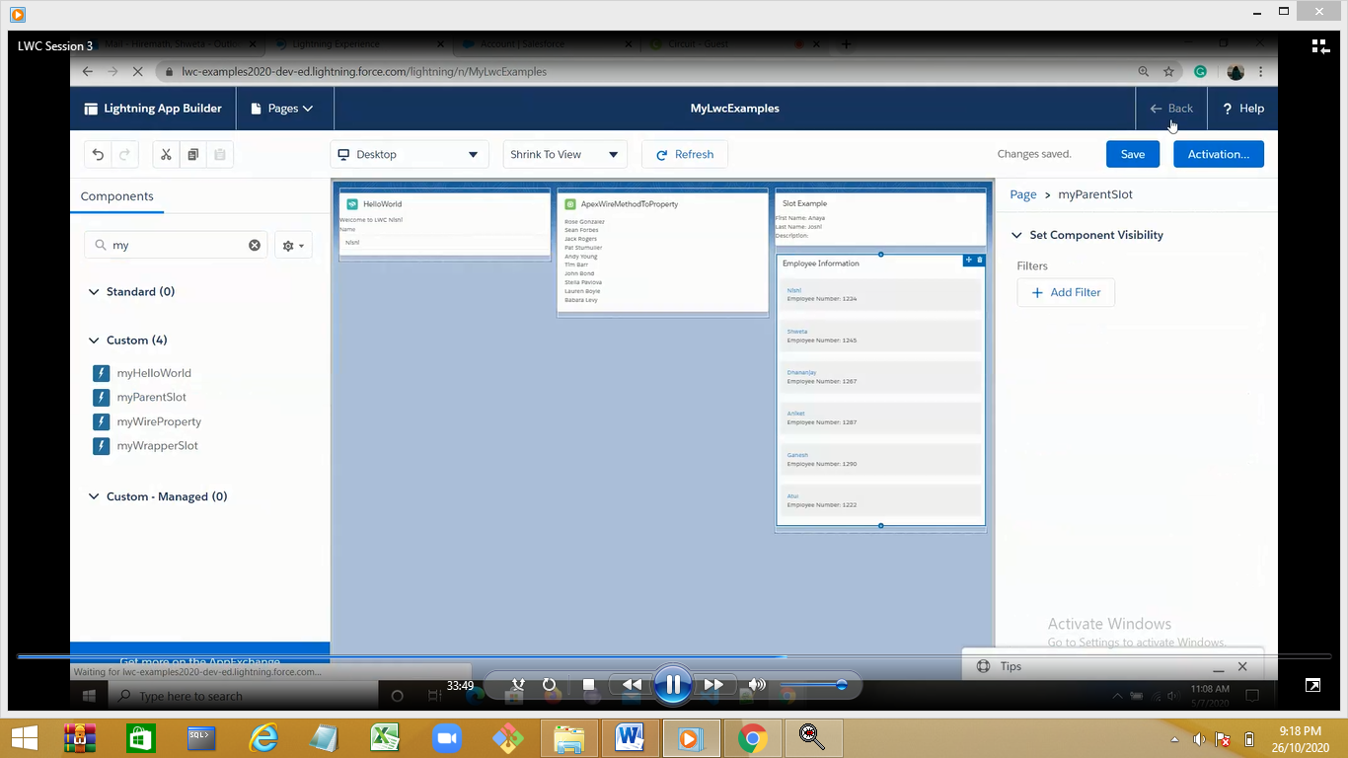

Demo :picklist account object

Create a new component myFetchPicklListValues

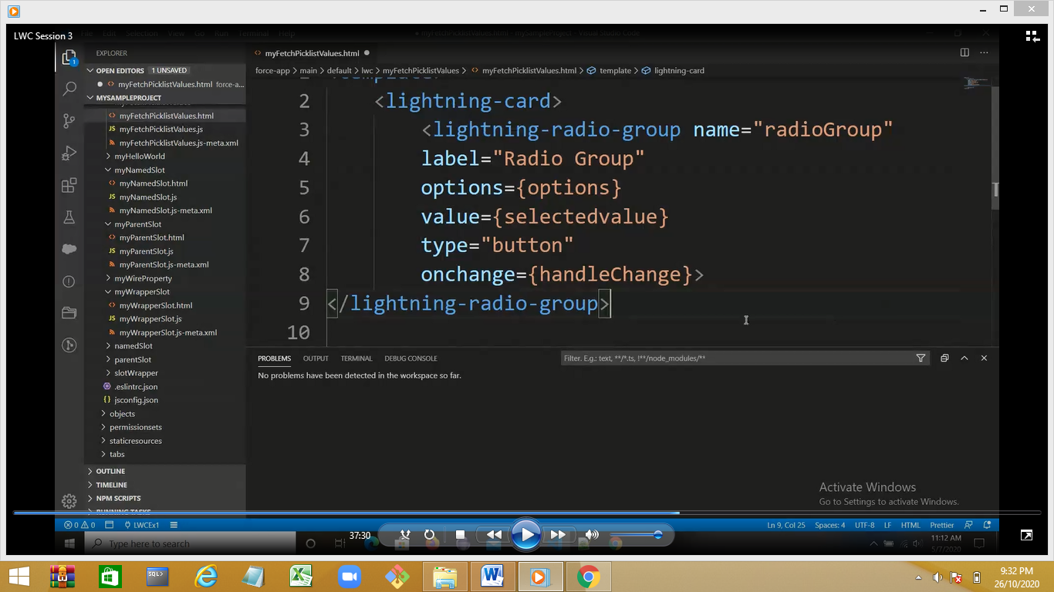

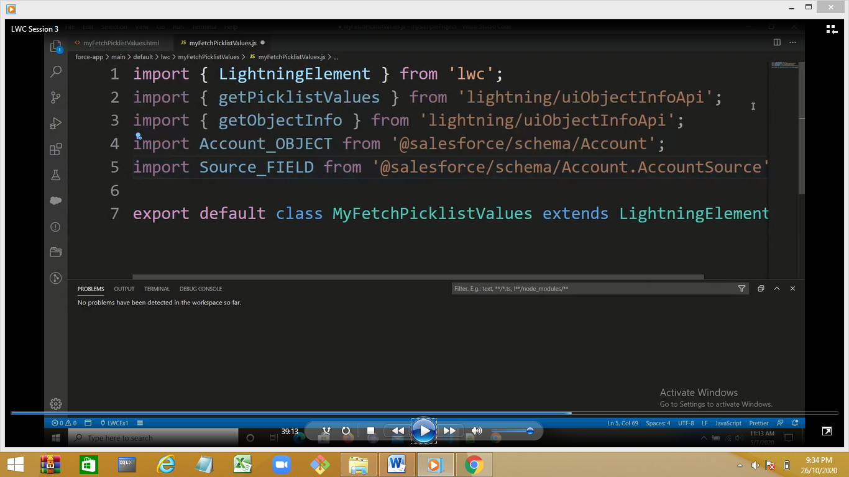

Type is button 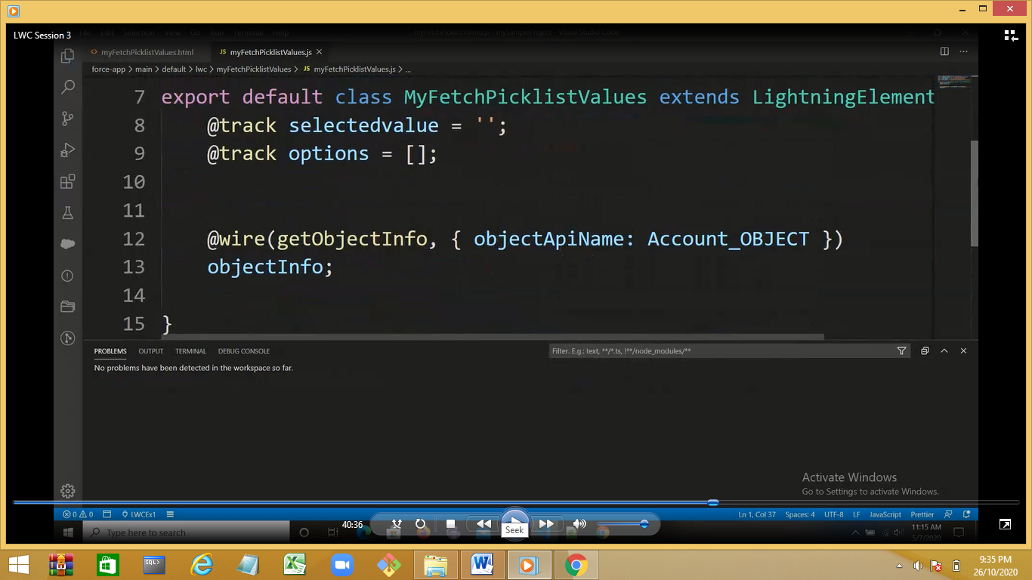

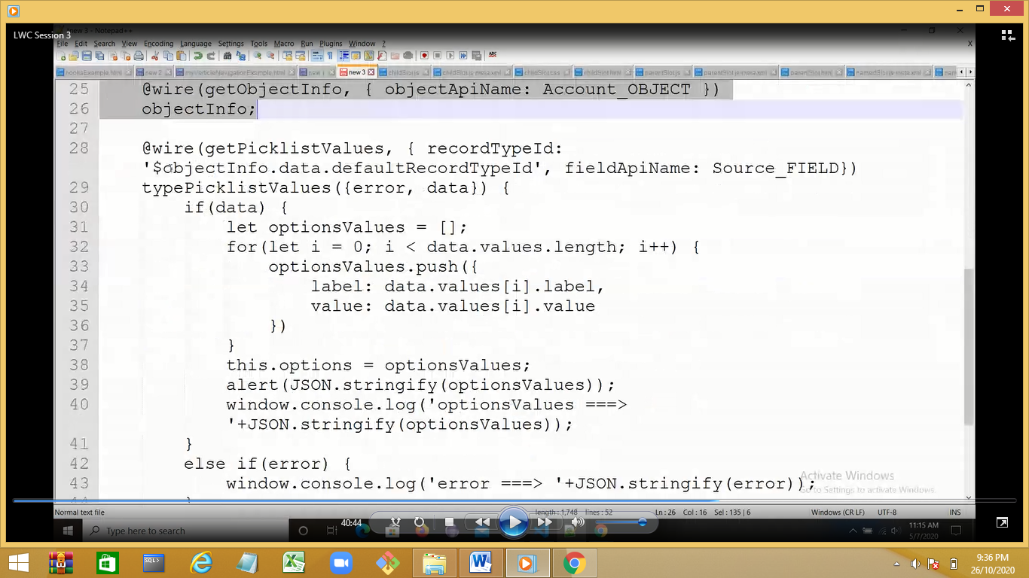

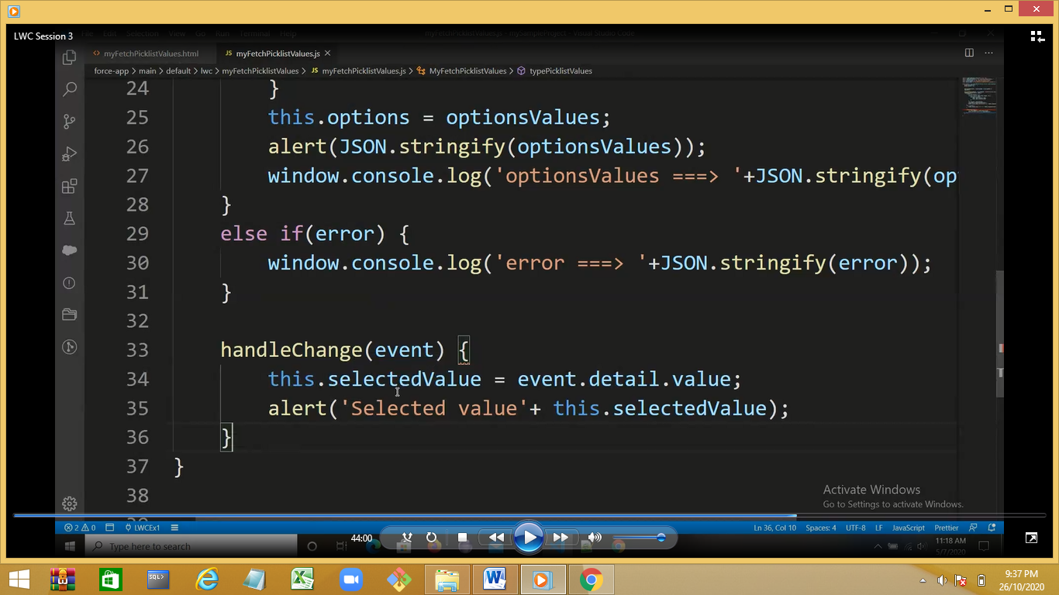

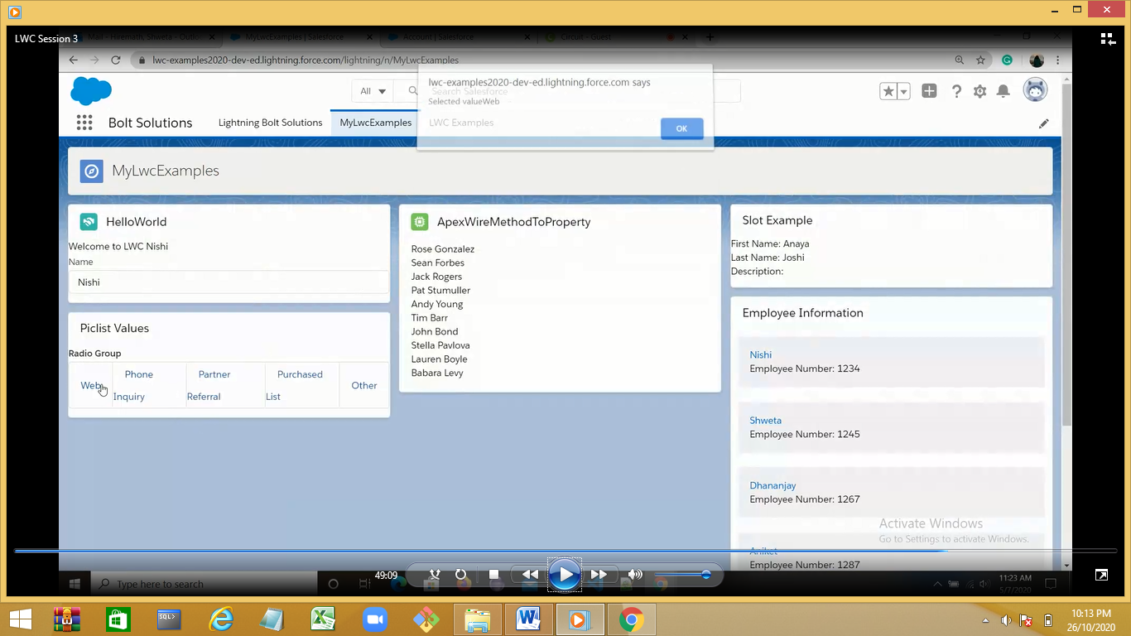

Basic navigation Demo:

https://developer.salesforce.com/docs/component-library/documentation/en/lwc/lwc.use_navigate_basic

(all lightning component)

Demo on

Lightning –vertical-navigation

Lightning-accordion

<https://developer.salesforce.com/docs/component-library/bundle/lightning-accordion/documentation>

template.querySelector???

lightning-layout

lightning-layout-item<https://developer.salesforce.com/docs/component-library/bundle/lightning-vertical-navigation/example>

<https://developer.salesforce.com/docs/component-library/bundle/lightning-layout-item/example>

<https://developer.salesforce.com/docs/component-library/bundle/lightning:layout/example#lightningcomponentdemo:exampleLayoutVerticalStretch>

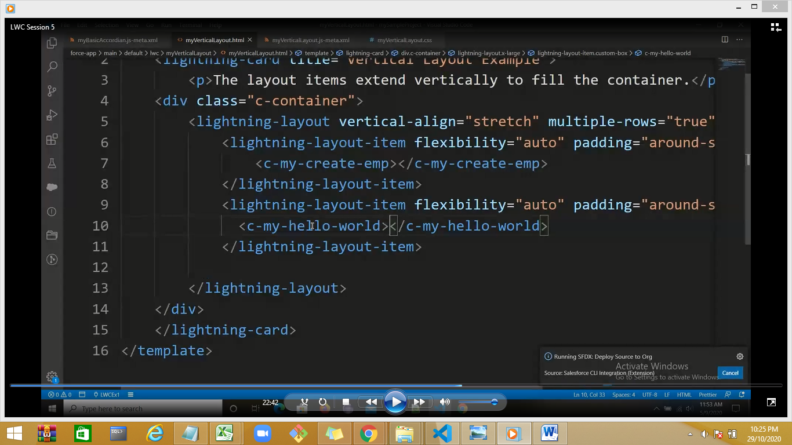

Progressbar

<https://developer.salesforce.com/docs/component-library/bundle/lightning-progress-bar/example>

